1st Prize: Queen Size Quilt
Tickets $1.00 each or 6 for $5.00
Quilt Top Done By: Chris Poprawski, Linda Godley, Martha Church, Barbara Grutter and Arlene Schoff
Quilting Done by: Esther Devormer-Patchwork Dreams

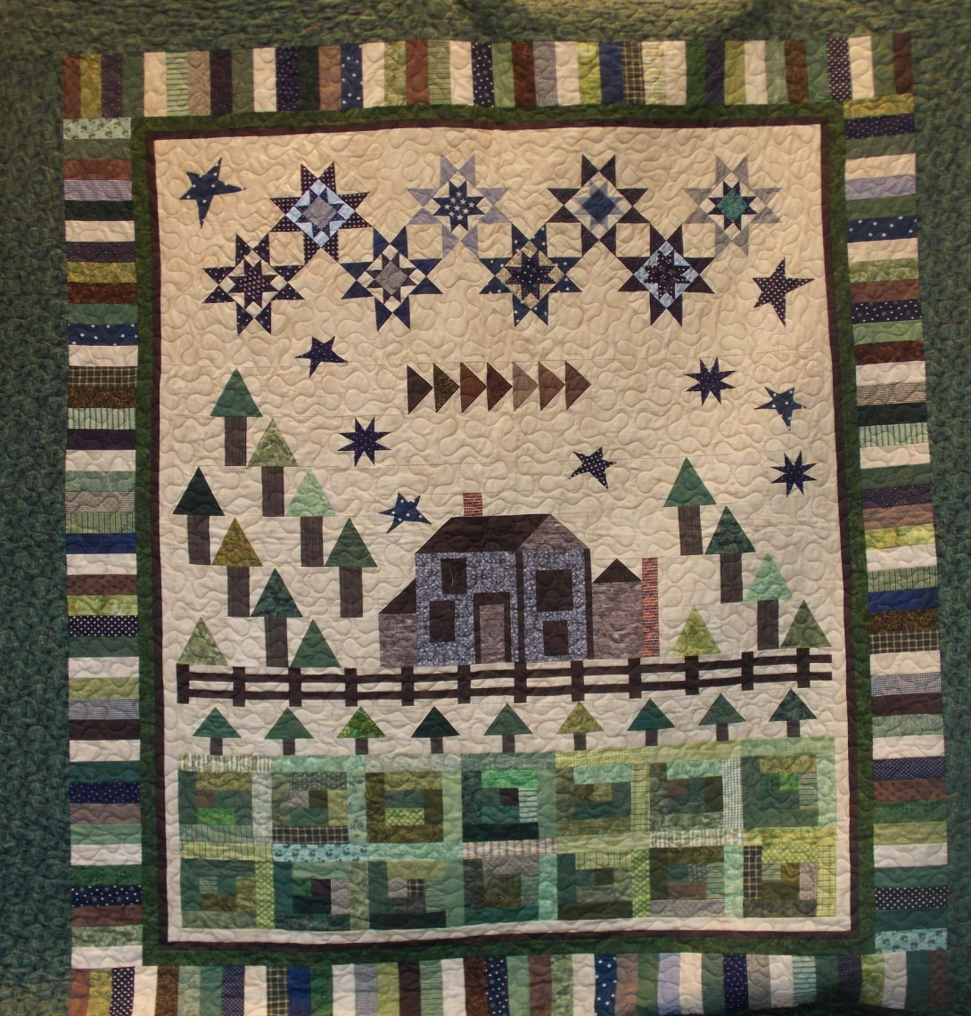
Drawing Date: Saturday, Sept 20, 2014 at 3:30 p.m.
Place: Ensley Park Pavilion,
Howard City Harvest Festival
On Display at:
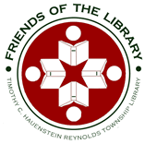
Timothy C. Hauenstein Reynolds Township Library
Need Not To Be Present To Win.

